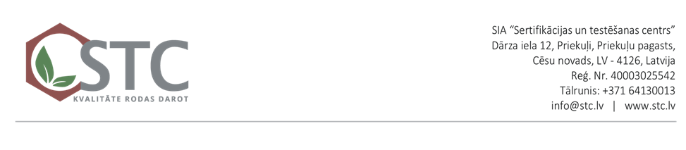

XX.XX.XXXX. No. XX/XXXX

Operator (enterprise)

Legal address

Position, full name of the head

e-mail

**Notice of Denial of Certification/Confirmation**

Based on the concluded agreement No._____ dated __________________ between SIA “Sertifikācijas un testēšanas centrs” and the Customer ________________ on the initial assessment of documentation for compliance with agricultural organic production, the following was stated 1) In ____________ with number No. _________,   
the Application for the initial assessment of documentation for compliance with the requirements of agricultural organic production was registered

2) In _______________ with number No._________, a contract was concluded for the initial assessment of documentation

The reason for refusal of certification is the following

|  |  |  |
| --- | --- | --- |
|  |  | The declared activity is not subject to certification in accordance with regulations |
|  |  | Insolvency proceedings have been announced for the applicant |
|  |  | The certification body has identified risks of independence or impartiality |
|  |  | Temporary restriction on certification of a specific type of product |
|  |  | Other unforeseen circumstances__________________________________________  ________________________________________________________________________ |

If the identified reasons for the refusal are eliminated, the Applicant has the right to contact the certification body by submitting a new application.

|  |  |  |
| --- | --- | --- |
| Head of the Organic Agriculture Sector in Third Countries |  |  |
|  | Signature | First Name Last Name |